Across
- Note: save long chore for when this is broadcast (6,8)
9 Suffering anger on a Sunday (7)
10 One note or another in accounts of agreements (7)
11 Regretted being impolite, or so we hear (4)
12 ‘Of these the false ____ was first’ (Dryden) (10)
14 Sovereign artist, scraping a few things together (6)
15 Regular payment for an old servant (8)
17 Deceive presumed winners in musical events (8)
18 Long passage with layer of mortar (6)
21 Trust God in saying the Creed? (3,2,5)
22 ‘King of Egypt’, by the sound of it, is a card game (4)
24 Radical follower of Karl or Harpo (7)
25 ‘_____, thou earth, at the presence of the Lord’ (Ps 114) (7)
26 Whether it’s dative or ablative, however things turn out (2,3,4,3,2)

Down
- Another name for a skipper? (7)
- After uttering ‘Lent Hilary summer etc’, still talking to each other (2,8,5)
- Song lacking introduction is still a song (4)
- Timothy’s mother, you said, is attractive (6)
- Cutter reversed before being dug up and tested (8)
- Can’t cross a roundabout; it’s inviolable (10)
- Abner, By The Organ might be Jane’s publishing debut (10,5)
- Horseman at an inn (6)
13 Find the Father in it, adapted for believers of all kinds (10)
16 ‘The pond’, territory briefly incorporated by Greek (8)
17 Protective spells burn document (6)
19 See Peterborough? (7)
20 Announces Victoria, Virginia and others (6)
23 Seabird’s name replaced by M (for Michaelmas?) (4)

CROSSWORD NUMBER 368
by Succentor
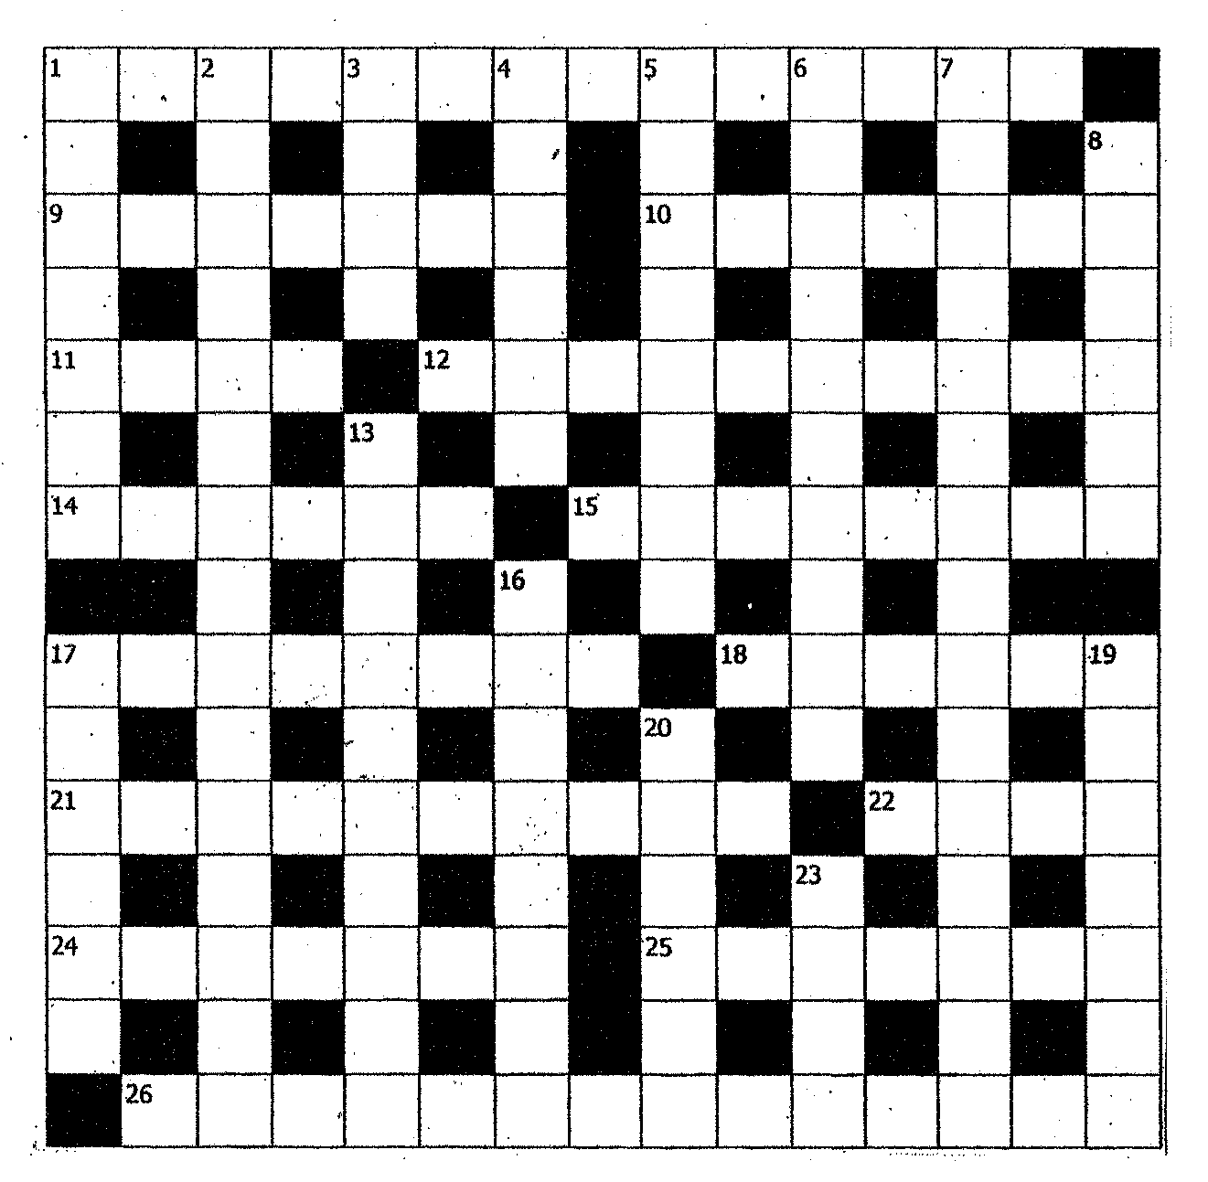
SOLUTION TO LAST MONTH’S PUZZLE

