Across
- Untidy person working among crops? (9)
8 Worship accessory for just part of the UK? (7,6)
11 Each distortion is pain (4)
12 ‘Almost correct’; argument not finished in diocese (5)
13 Is she a morning person? (4)
16 Sal and 21 could name a beloved son (7)
17 ‘And the red glare on ___ roused the burghers of Carlisle’
(Macaulay) (7)
18 Country where people interrupt the song? (7)
20 Disorganised curate carrying note for mythical being (7)
21 ‘O Lamb of God’ from reading-desk? Just the opposite (4)
22 Musical ornament from birdsong (5)
23 Bananas being sent back for It’s A Knockout! (4)
26 Initial ordeal as sacrament administered in wrong element (7,2,4)
27 Eire faces trouble with end of hostilities (5-4)

Down
- Prehistoric tool for Saxon predecessor (4)
- Platform to criticise heartlessly – that’s strange (7)
- Sticks together and makes sense (7)
- Official communication for resistance units (4)
- Sharing a problem, like the owl and the pussycat? (2,3,4,4)
- If complete, this makes an old comedy show (3,3,7)
- Meat returned to an Indian ruler makes him a greater ruler (9)
- Swearing wildly about name in response (9)
14 Ostentatiously put down cheap wine (5)
15 ‘Like as the arrows in the hand of the ____’ (Ps 127) (5)
19 Sorts AI to generate Greek tenses (7)
20 Cancel visit; it’s not on (4,3)
24 Fashion lacking line is an eyesore (4)
25 A service set up some distance away (4)

CROSSWORD NUMBER 372
by Succentor
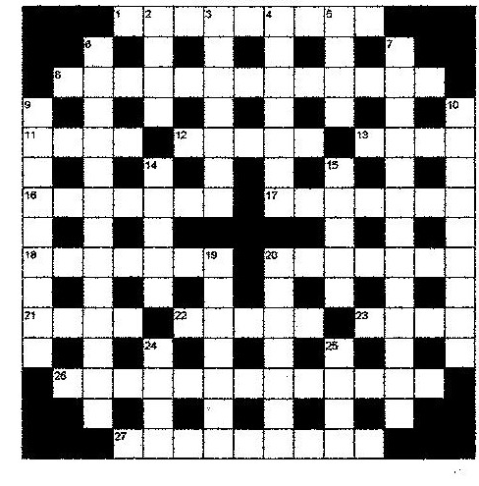
SOLUTION TO LAST MONTH’S PUZZLE

